Summary of Research Findings Regarding the Effects of Private School Choice Programs
Dr. Patrick J. Wolf
Distinguished Professor in the University of Arkansas Department of Education Reform
Updated May 14, 2025

Different Kinds of School Choice Studies (modified from Kirki Agrawal, n.d.)
- The rigor of any private school choice evaluation depends heavily on how individual students got into the choice program or the public-school comparison group. Was it by free choice or by random chance? The more that it is by free choice, what researchers call “self-selection,” the more we worry that any outcome differences for the private school student is due to advantages that drove them to get into private school and not due to the private school choice program or private schooling itself.
- The least rigorous studies are straight comparisons of student outcomes in private versus public schools. For those, any differences between outcomes are due to some unknown mix of student background and school influences. Since we can’t know what effect private schooling had in those case, none of those straight comparison reports are included here. Observational studies similarly allow students to self-select into private schools or public schools but at least control statistically for some (but probably not all) background factors that otherwise might bias the comparison. Quasi-experimental (QE) studies leverage some aspect of program access, such as student age or distance from school, that limits the ability of students to fully self-select into private or public schools. That makes QE studies more rigorous than observational studies. Finally, experimental studies are the “gold standard” for rigor because, among a group of interested students, mere chance determines if they access private schools through a choice program or serve in the public-school control group.
- A meta-analysis is a systematic and scientific consolidation of the results of similar studies on the same question to get a sense of what happens, generally, when students participate in a program.

Achievement Effects of School Choice on Participating Students Lean Positive (all experimental studies)
- A meta-analysis of 21 studies from around the world finds that students in choice programs drop slightly in achievement initially, as they adjust to their new school, then tend to surge ahead of their control group peers by the second year in reading and the third year in math, demonstrating large gains by the fourth year and beyond (Shakeel, Anderson & Wolf 2021).
- For the 18 experimental studies of U.S. programs, 8 report positive effects of the choice program on test scores for the full sample of students (e.g. Wolf et al. 2013), 4 report no effects for the full sample but positive effects for disadvantaged students (e.g. Barnard et al. 2003), 4 report no effects for the full sample or any specific subgroup (e.g. Webber et al 2019), and 2 (both of the now defunct Louisiana Scholarship Program) report negative effects on the full sample (e.g. Mills & Wolf 2019).

Participating Students Consistently Improve in Educational Attainment (mix of experimental, quasi-experimental & observational studies)
- 4 of 5 findings on the effects of choice programs on high school graduation are positive (Cowen et al. 2013; Erickson & Scafidi 2020; Warren 2011; Wolf et al. 2013), while the remaining finding is of no effect (Austin & Pardo 2021)
- 8 of 9 findings on the effects of choice programs on college enrollment are positive overall (Austin & Pardo 2021; Chingos, Figlio & Karbownik 2025; Chingos, Monarrez & Kuehn 2019; Erickson & Scafidi 2020; Wolf, Witte & Kisida 2019) or at least for disadvantaged subgroups (Chingos & Peterson 2015; 2021; Erickson, Mills & Wolf 2021), while the remaining finding is of no effect (Chingos 2018)
- All 5 findings on the effects of choice programs on college completion are positive overall (Chingos, Figlio & Karbownik 2025; Chingos, Monarrez & Kuehn 2019) or at least for disadvantaged subgroups (Cheng & Peterson 2021; Chingos & Peterson 2015; Wolf, Witte & Kisida 2019)

Civic Effects of Private Schooling are Consistently Neutral or Positive (mostly observational studies)
- Of 531 findings on the effects of private schooling or private school choice on political tolerance, political participation, political knowledge, and community engagement, 168 (32%) are positive, 320 (60%) are neutral and only 43 (8%) are negative (Figure 1)

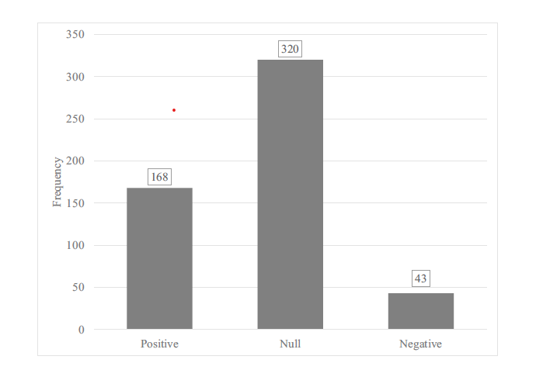
Figure 1. Meta-analysis findings regarding the effects of private schooling on civic outcomes (Shakeel et al., 2024)

Crime & Mental Health Effects on Participating Students are Neutral to Positive (only a few observational studies)
- States experience declines in adolescent suicides after adopting expansive school choice programs and adults report fewer visits to counselors or therapists if they attended private schools in their youth (DeAngelis & Dills 2018)
- Participants in the Milwaukee school voucher program 2006-2012, when tracked at age 22-25, had committed 86% fewer property crimes, 53% fewer drug crimes, and were involved in 38% fewer paternity suits than carefully matched students who had attended Milwaukee Public Schools (Figure 2)

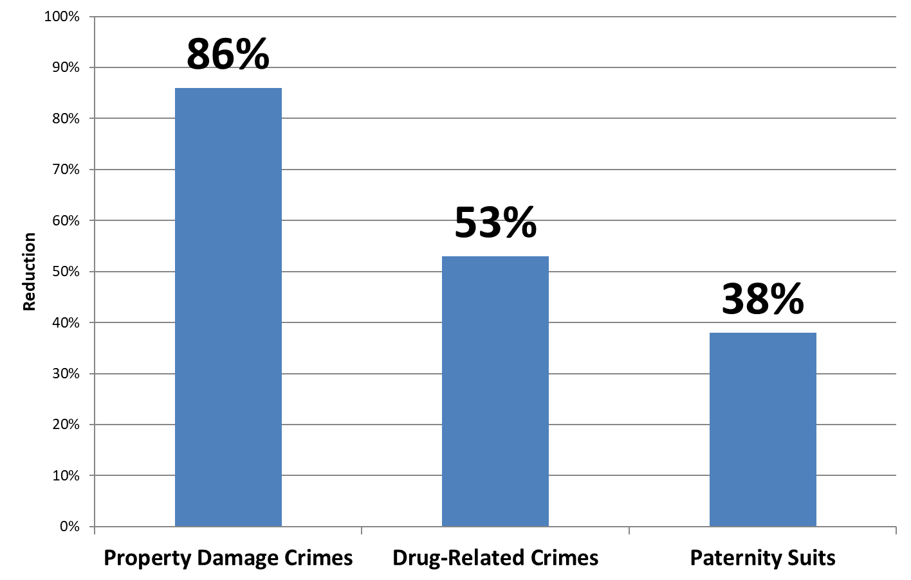
Figure 2. Reductions in crime or judicial proceedings due to participation in the Milwaukee Parental Choice Program (DeAngelis & Wolf 2020)

Achievement Effects on Non-participating Students due to Competition are Consistently Positive (all quasi-experimental studies)
- 27 of 30 statistical studies report positive, though small, effects, with one study finding only neutral results and two reporting a mix of neutral and negative effects
- A meta-analysis of all the studies concludes: “Overall, we found small positive effects of competition on student achievement [in public schools].” (Jabbar et al. 2022)

